Experiment 2

# Aim:

a) Develop and demonstrate, using Javascript script, a XHTML document

that collects the USN ( the valid format is: A digit from 1 to 4 followed

by two upper-case characters followed by two digits followed by two

upper-case characters followed by three digits; no embedded spaces

allowed) of the user. Event handler must be included for the form

element that collects this information to validate the input. Messages in

the alert windows must be produced when errors are detected.

b) Modify the above program to get the current semester also (restricted

to be a number from 1 to 8)

# Experiment 2a: USN Verification

# XHTML:



Code : 2a.html

# Javascript:



Code : 2a.js

# Output:

## Valid USN case:

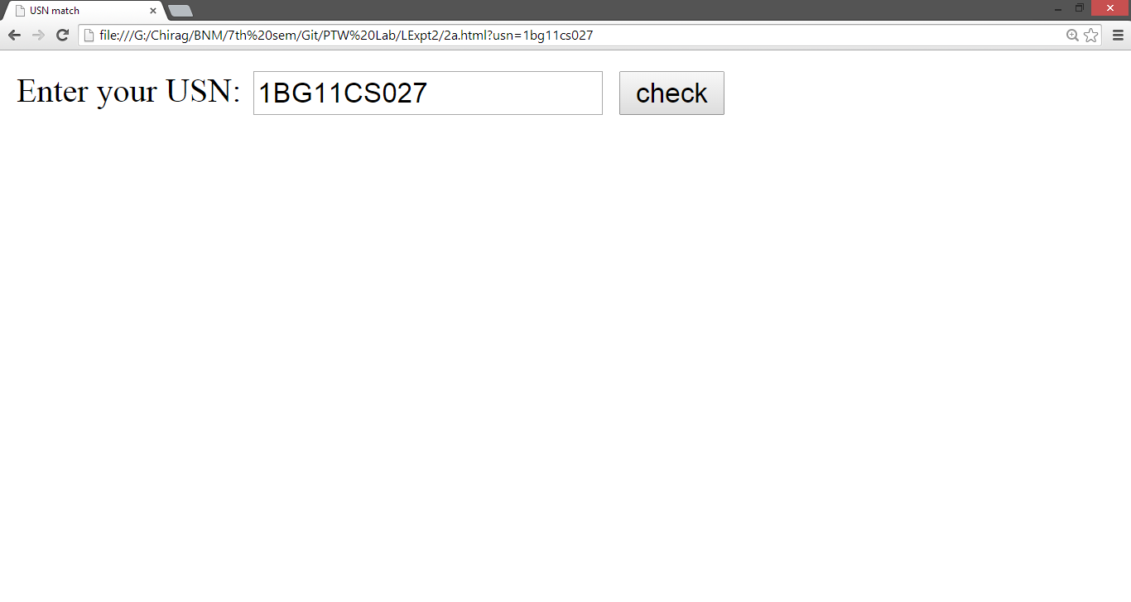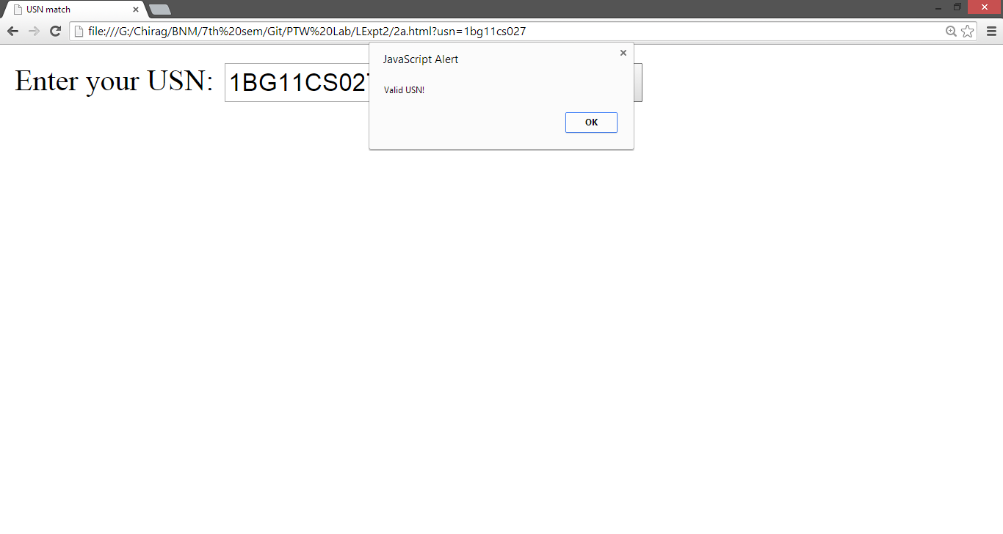

## Invalid USN:

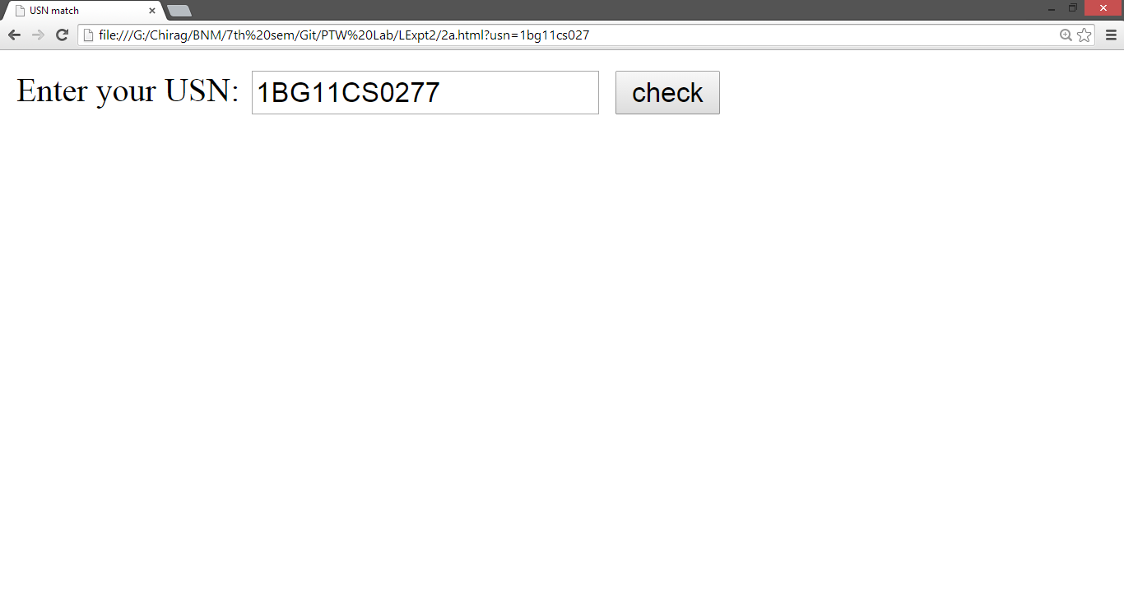

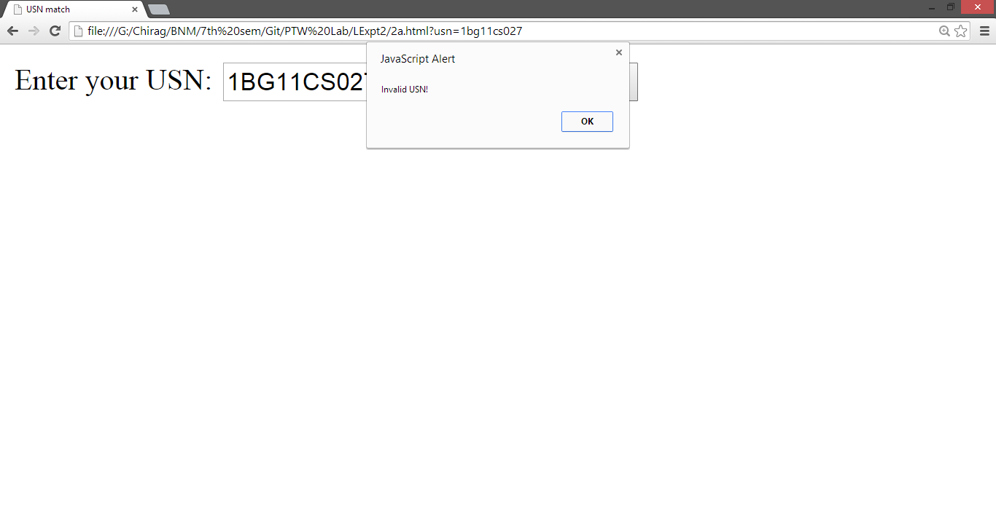

# Experiment 2b: USN and Semester Verification

# XHTML:



Code : 2b.html

# Javascript:



Code : 2b.js

# Output:

## Valid USN and semester:

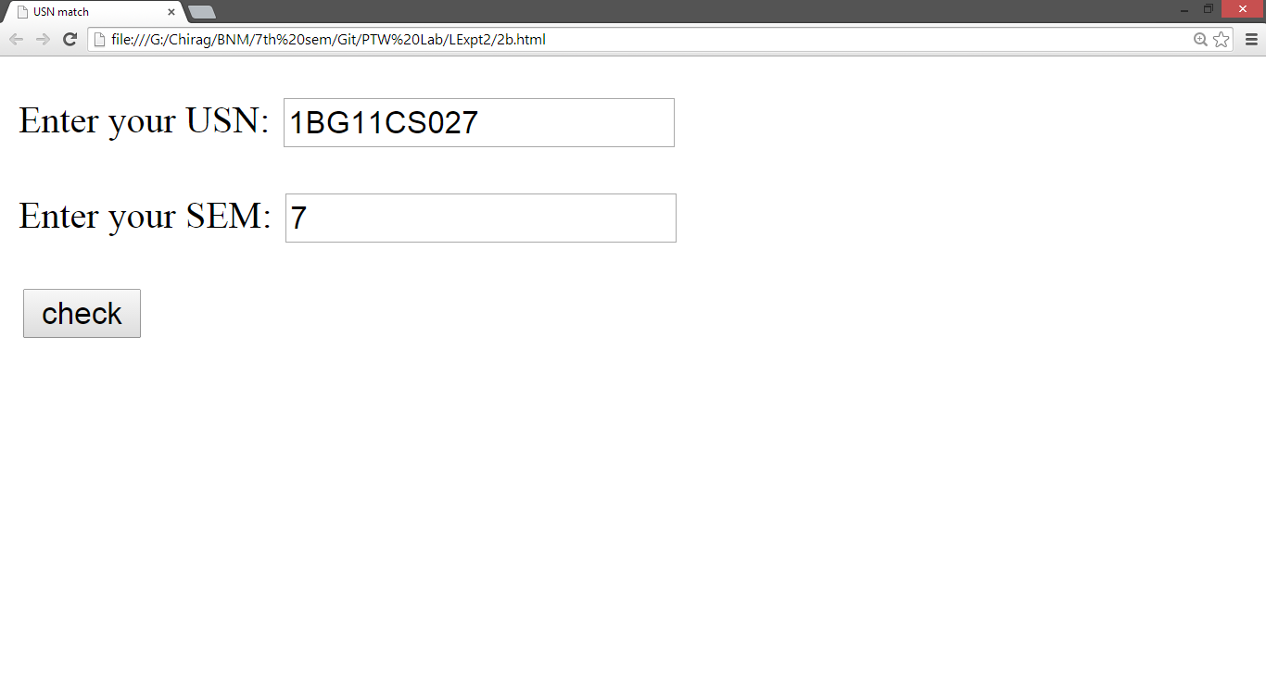

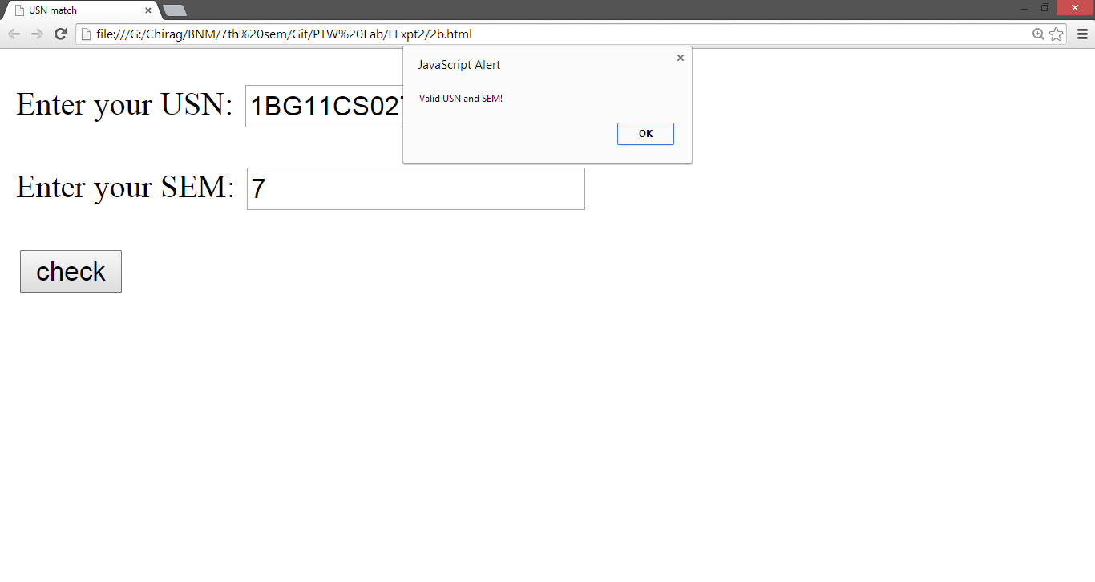

## Invalid USN and valid semester:

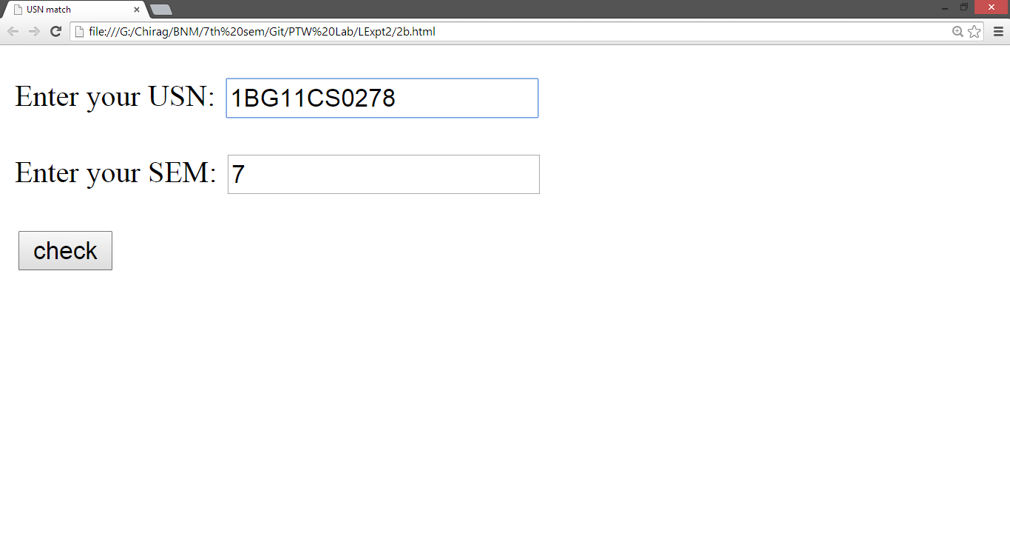

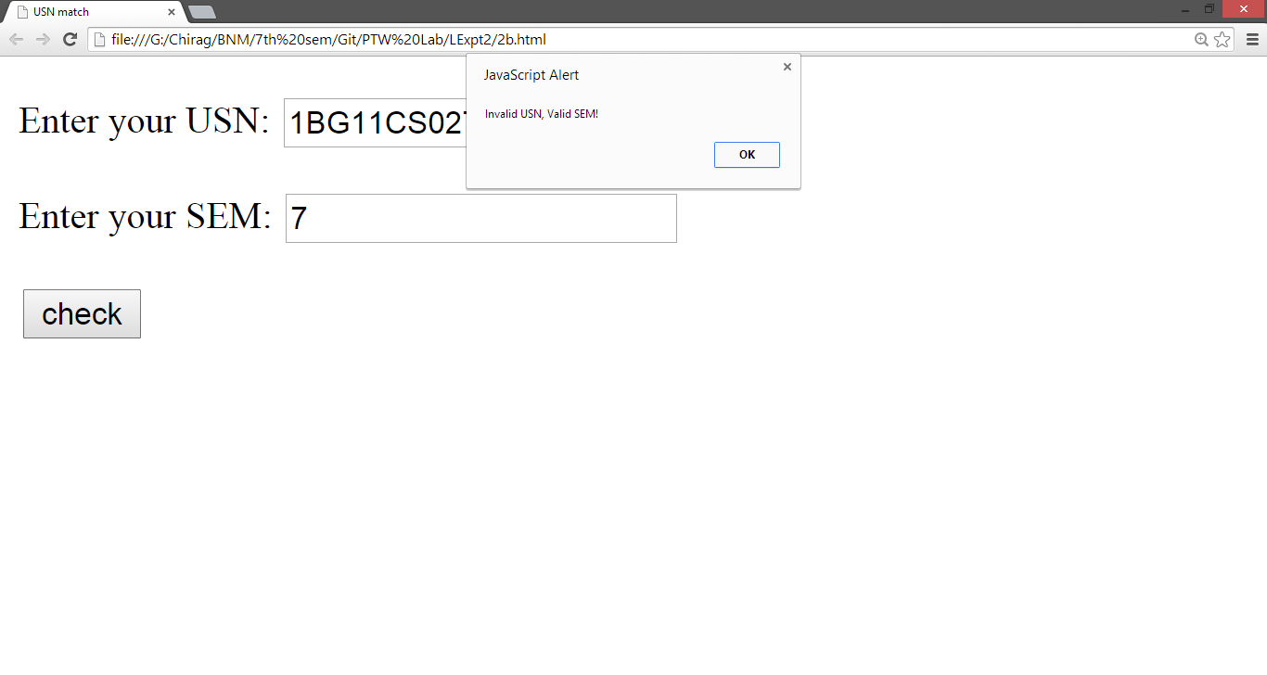

## Valid USN and invalid semester:

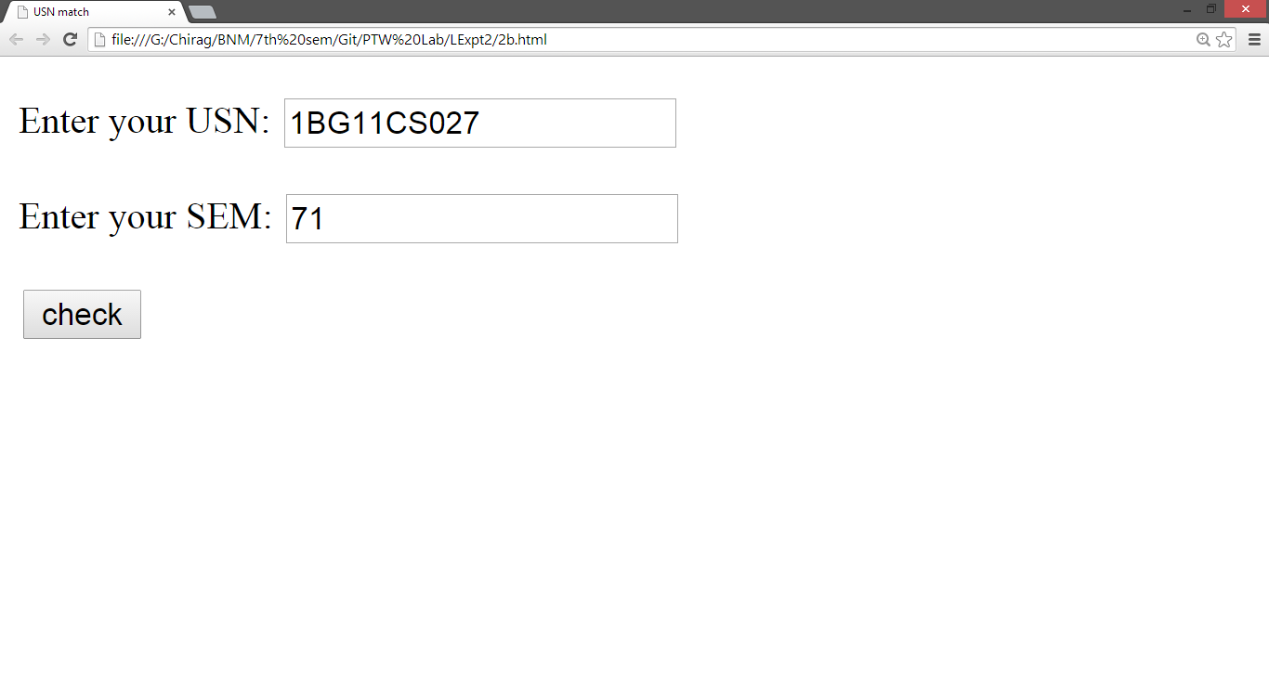

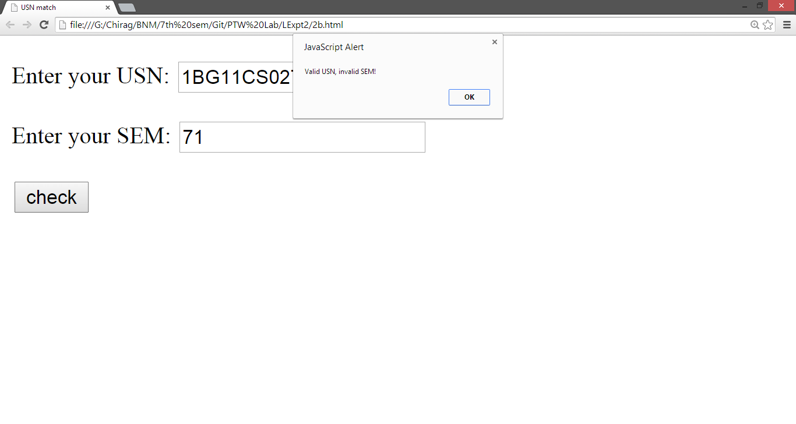

## Invalid USN and semester:

